

Lamplight: Design Documentation

600090: Commercial Games Development ACW 2



By:

Damon Moore

Stephan Zaneboni

Eleanor Woodhouse

Olumide Osikomaiya

Efren Krauss

Contents

1. Concept Design 2

1.1. Initial Design Concept 2

1.2. Character design 2

1.2.1. Hunters 2

1.2.2. Ghosts 2

1.3. Game mechanics 2

1.3.1. Perspective and Control System 2

1.3.2. Environment and interaction 3

1.3.3. Lobby System 3

1.4. Level Design 3

1.5. Aesthetics 4

2. Roles & Task Breakdown 4

2.1 Game Mechanics & Design (Olumide/Eleanor/Efran/Damon) 4

2.2 UI Design (Stephan) 4

2.3 Lighting & Physics (Damon) 5

2.4 3D Modelling and Animation (Efran) 5

2.5 Report (All) 5

3. Market Research 5

4. References 6

5. Appendices 7

5.1 Time Plan (Figures 1 & 2) 7

5.2. Extended Time plan (Figure 3) 9

5.3. Concept Sketches (Figure 4) 10

5.4. Use Case Diagrams (Figures 5,6,7,8) 10

# Concept Design

## Initial Design Concept

*‘Lamplight’* is designed as a team-based, local-multiplayer casual party game set in a haunted building, where players are divided into two teams, *Hunters* and *Ghosts.* The Ghosts inhabit the building and have the goal to prevent all the lamps in the rooms from being lit without being seen and eliminated by the hunters. Whereas the goal of the Hunters is to keep the lamps ignited, whilst also chasing and eliminating the *Ghosts*. The *Hunters* can win by either eliminating all the *ghosts* or by lighting all the lamps. The *Ghosts* can only win if all the light sources within the game have been extinguished.

## Character design

### Hunters

Hunters have been designed to be the main antagonist of the game, featuring a ‘ghost vacuum’ alongside a lamp to light the light sources with. The aim of the hunters within the game is to eliminate ghosts whilst also ensuring that all light sources are light throughout the building. This will be achievable through the hunter pressing the ‘Interact’ button that will launch a net in the same given direction in-front of the player, capturing the ghost and locking them in place. The game will end in victory of the hunters should either of these objectives be fulfilled. Hunters will also have a decreased movement speed in comparison to the ghosts to allow better balancing and environmental immersion within the game (Figure 5).

### Ghosts

Ghosts however have been designed to be the most encountered form of player within the game. Numerous and without the inability to fight back, they must extinguish all light sources from the environment to plunge the hunters into complete darkness. Ghosts will remain invisible to all players despite being on a shared screen, with minor contextual clues as to their locations such as kinetic movement interaction with objects and opaque indications when near or interacting with light sources. Ghosts will have the ability to interact with ‘Small’ Objects such as books or small tables in order to create a distraction for the hunters, of which will launch them similar to the hunter’s net in the direction which they are facing. Friendly ghosts may also free their teammates through standing near a netted ghost, gradually filling a progress bar similar to that of capturing lamp sources; which in turn will gradually decrease should they move away (Figure 6).

## Game mechanics

### Perspective and Control System

The game is in a 3D top-down perspective, displaying the game map to all players at the same given time. The game is designed to work with air controllers, with movement and look-aim controlled separately that will be utilized using ‘AirConsole’ technologies to allow mobile phones as the controlling source. Within this interface, players, either hunter or ghost, will be able to navigate using an analog control stick alongside an interaction button. This button will allow ghosts to spook a hunter to temporarily incapacitate them, likewise with a hunter they will be able to capture ghosts with a net device that will immobilize the ghost player until they are freed by friendly teammates. Both forms of players will also be able to interact with lamps by standing within an area of influence, gradually increasing the capture rate to whomever has the most weight within the radius. This ‘capture’ rate will be displayed on a progress bar to indicate the time remaining in order for either side to capture the lamp, with the addition of showing the decreasing time should both parties leave the circle of influence (Figure 5; Figure 6; Figure 7).

### Environment and interaction

The map will be presented as a single floor haunted house plan consisting of many labelled rooms, connected through highlighted passageways. Household and environmental objects will be present throughout the map, with some remaining static in place and others becoming interactable. Interactable objects will allow basic physics to occur to allow players to push them around the game world and utilize them to their advantage, despite slowing them down when moving the objects, by either blocking passageways temporarily, or slowing down an opponent.

### Lobby System

The lobby system will operate through presenting a basic UI interface that will inform all players of the current hunter and ghost connected mobile controllers. Within a game lobby, there will be a finite number of ghost and hunter players, with a balanced 4:1 ratio respectively to ensure that the game remains both immersive and novel to play. Once a certain threshold has been reached, the game will be able to start by navigating on the display screen and interacting with a ‘Start Game’ button. This should in turn then display a uniform interface on the mobile devices and start the game world, spawning each type of player randomly within rooms (Figure 8).

### Level Design

The level will be composed of a variety of rooms that are interconnected through hallways, creating an identical scenario to what could be considered a ‘Pre-War Mansion’. The map will feature only the ground floor, with a variety of thematic rooms differing in content, each containing the possibility to have a lamp spawn within them at the time of game creation. In addition, these rooms are all passable through doors, that can be pushed by either player to gain entry or blocked should the players decide to push interactable objects from said rooms, small or large, in front of them. In terms of atmospheric enhancement for the players, an outside garden area will be present to improve the immersion, however, will not be accessible to the players. Based on a random timer, various light sources, such as lightning, will illuminate the mansion, allowing various gameplay features such as revealing ghosts to occur (Figure 4).

### Aesthetics

The aesthetics will be encompassing a family-oriented environment in order to become more accessible to a larger market audience. As a result of this, the graphical aspects of the game will remain suitable, simple and attractive to all audiences, with textures and lighting following suite to further boost the immersion and appeal of the game. All models produced will be low polygon count and textured, with various objects such as hunters and ghosts retaining a ‘quirky’, but comical animation to them. Lighting, sound and music will also be implemented to create an atmosphere of mystery and immersion, with the mansion layout being incredibly dimly lit through a variety of light sources. External lighting such as lightning strikes or sounds such as creaking floorboards depending on areas which players walk on top of will also form an extra level of immersion.

# Roles & Task Breakdown

Due to the nature of the game, various roles have been combined to achieve maximum potential within the given time frame. Despite this however, all members will remain flexible and able to shift to achieve milestones should delays occur when meeting the deliverable targets.

## 2.1 Game Mechanics & Design (Olumide/Eleanor/Efran/Damon)

This role entails the creation and implementation of core game mechanics alongside environmental design to produce the game world that players will operate within. The tasks within this role are highly varied to one another, but ultimately don’t involve the creation of backend design nor pure art implementation as found with the lighting and 3D modelling respectively.

Tasks involve:

* Creation of the game environment utilizing the lighting and aesthetical assets produced
* Creating and managing the code for game world interaction, player interaction for both ghost and hunter and win/lose conditions

## 2.2 UI Design (Stephan)

This role involves both the implementation and design of the UI Content that the players will utilize throughout playing the game, alongside creating and managing the scene changes and the AirConsole implementation systems.

Tasks involve:

* Creation of UI elements found within the game world and the menus, alongside the menu’s and interaction elements themselves
* Handling and creating the back-end systems to utilize AirConsole as the controller

## 2.3 Lighting & Physics (Damon)

This role, whilst similar to the environment design itself, will focus more-so on the implementation of the back-end systems required rather than the design itself, creating the fundamental systems for interaction and environmental immersion

Tasks involve:

* Creation and implementation of lighting and physics based back-end systems to allow game design members to apply modular interactions with the game environment

## 2.4 3D Modelling and Animation (Efran)

This role will involve the production of assets to form the game world, with tasks ranging from modelling to texturing and rigging / animation of the models themselves.

Tasks involve:

* The creation of the assets for the game world utilizing the full design pipeline, from creation of the models to texturing and animation/rigging within the relevant software, ready for design members of the team to utilize

## 2.5 Report (All)

The report itself consists of the conceptual designs introduced, all the way to the implementation and evaluation of the fundamental architecture and designs. All members will contribute to the report, with the most apparent contributions arriving from their respective main roles within the team.

# Market Research

LampLight sits in the genre market of local multiplayer and party games. According to a consumer research survey published by Statista in 2016, games people would be considered casual are played by 27% of the surveyed UK population and games considered party games are only played by 18% of the surveyed. In a research analysis of sales in the US doesn’t even have casual or party games in its specific lists, the category of other taking 4.6% (Statista, 2019). Local multiplayer and party games appeal to people who are active with groups of people, examples include students and family members who have easy access to be playing with friends and other family members.

This makes the target market and the audience that purchases the games quite niche. While the amount of games to be competing against can be estimated to be lower as the consumer base is lower, but this means that have pierced into this market would have a much stronger hold on the market. It is more difficult to stand out against tried and tested franchises compared to other new upcoming titles. According to VGChatz, the highest selling party games on the Steam platform are as followed:

1. Stick Fight: The Game
2. Castle Crashers
3. Move or Die
4. Gang Beasts
5. The Jackbox Party Pack 3
6. The Jackbox Party Pack
7. The Jackbox Party Pack 2
8. Adorables
9. The Jackbox Party Pack 4
10. The Jackbox Party Pack 5

What is immediately apparent from the list above is that The Jackbox Party Pack series is the most dominant series in the party games market. While it doesn’t climb above the number 5 spot, multiple sequels take 50% of the top 10 showing people are committed to this franchise. With a total of 1.2 million units sold and the series being currently ongoing, it is a consistent front in the party game genre. One of the standout titles on the list is Castle Crashers. While this game was released in 2012, is still one of the highest local multiplayer games on the platform with an estimated 5 million copies sold on Steam it continues to hold its strong position (Vgchartz.com, 2020).  
Stick Fight: The Game is an example of a game that was able to break through the competitive barrier to sit on top of the bestselling games; released in 2017, the title with marketing boosts from content creators on platforms, currently now sits in at over 2 million titles sold and growing (Vgchartz.com, 2020).

# References

Statista. 2016. *Video Games Played In 2015, By Game Type | Statista*. [online] Available at: <https://www.statista.com/statistics/527986/uk-survey-video-games-played-by-game-type/> [Accessed 26 March 2020].

Statista. 2019. *U.S. Most Popular Video Game Genres 2018 | Statista*. [online] Available at: <https://www.statista.com/statistics/189592/breakdown-of-us-video-game-sales-2009-by-genre/> [Accessed 26 March 2020].

Steam Database. n.d. *Steam Database*. [online] Available at: <https://steamdb.info/> [Accessed 26 March 2020].

Steamcharts.com. n.d. *Steam Charts - Tracking What's Played*. [online] Available at: <https://steamcharts.com/> [Accessed 26 March 2020].

Vgchartz.com. 2020. *Video Game Charts, Game Sales, Top Sellers, Game Data - Vgchartz*. [online] Available at: <https://www.vgchartz.com/#embed_link> [Accessed 26 March 2020].

# Appendices

## 5.1 Time Plan (Figures 1 & 2)

#### Figure 1. Alpha content development cycle ranging from basic mechanics such as lighting interaction, to more advanced game mechanics entailing lobby joining systems

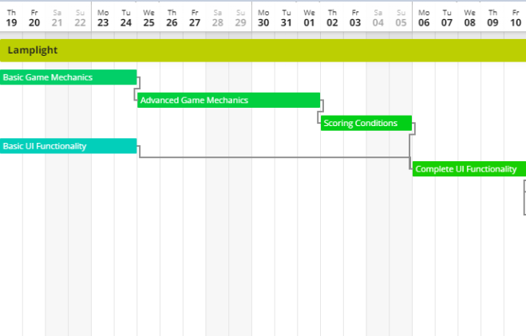

#### Figure 2. Beta content development cycle showing the finalization of the game, consisting of more polish than feature implementation

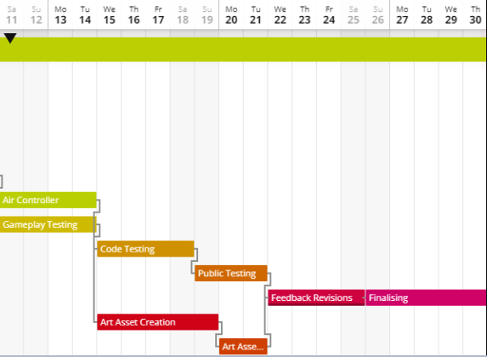

## 5.2. Extended Time plan (Figure 3)

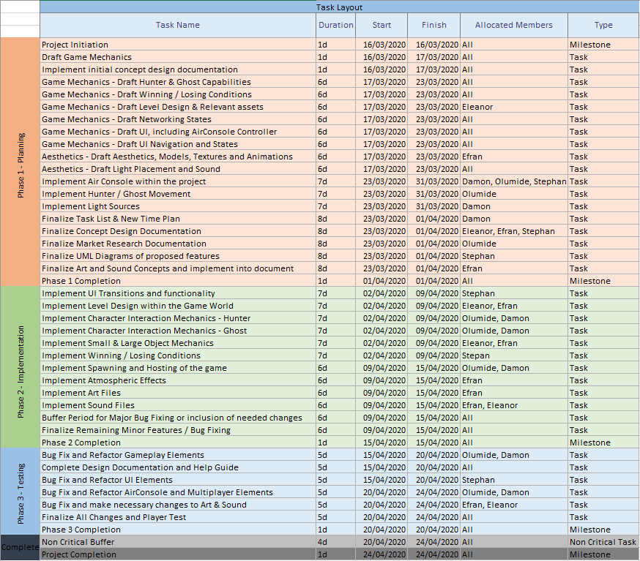

Figure 3: *Time plan detailing every major advancement within the project against the projected timeline date, each containing the duration and allocated members*

## 5.3. Concept Sketches (Figure 4)

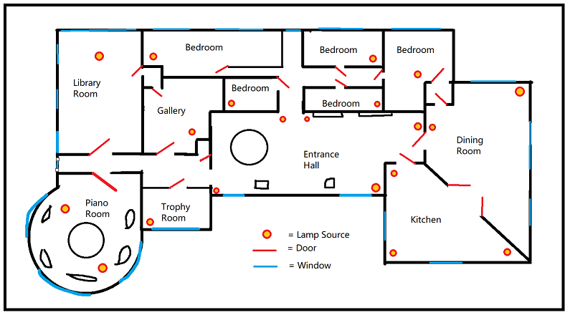

Figure 4: *Sketch of the level design floor plan used throughout the game, including the potential lamp source locations and the doorways*

## 5.4. Use Case Diagrams (Figures 5,6,7,8)

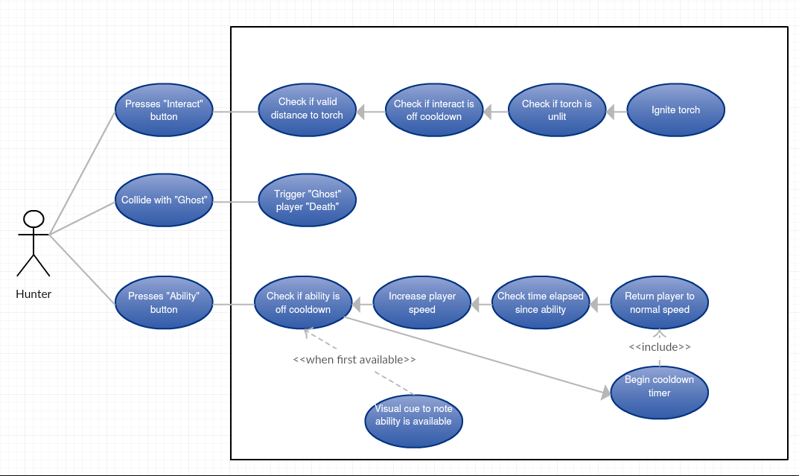

Figure 5: *Use Case Diagram detailing the interactions between hunters and game play mechanics*

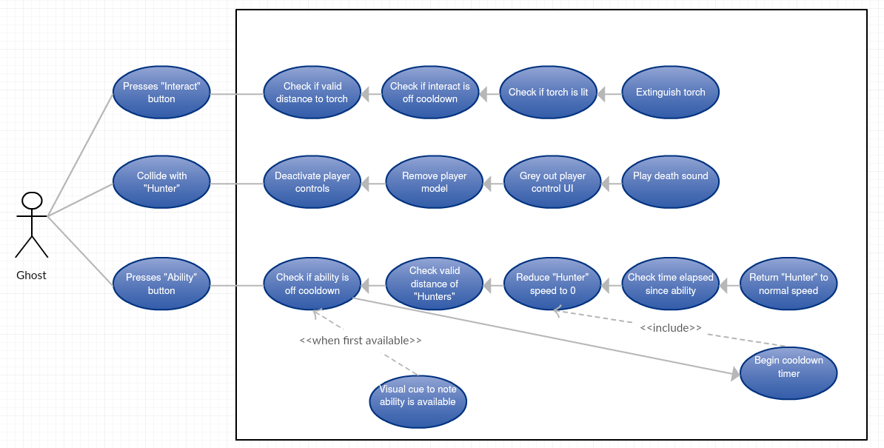

Figure 6: *Use Case Diagram detailing the interactions between Ghosts and gameplay mechanics*

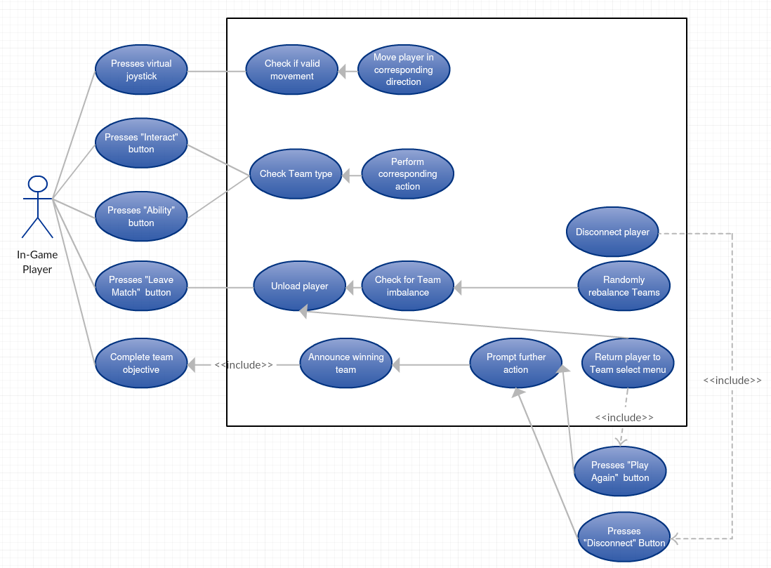

Figure 7: *Use Case Diagram detailing the shared logic between both the ghosts and hunter players within the game world*

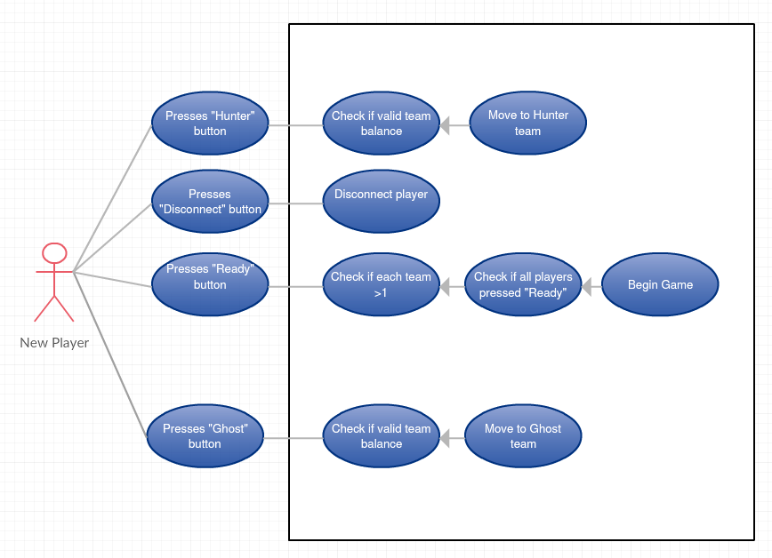

Figure 8: *Use case diagram detailing the behavior’s and mechanics that a new player would navigate through in order to enter the game world and begin playing*